  
  
**Assignment Cover Sheet**

|  |  |
| --- | --- |
| **Subject Code: CSIT128** |  |
| **Subject Name: Intro to Web Technology** |  |
| **Submission Type: Assignment Phase 1** |  |
| **Assignment Title:** |  |
| **Student Name: Ibrahim Ahmed Siddiqui** |  |
| **Student Number: 7352396** |  |
| **Student Phone/Mobile No. 0503039378** |  |
| **Student E-mail: ias677@uowmail.edu.au** |  |
| **Lecturer Name: Professor Soly Mathew** |  |
| **Due Date:** |  |
| **Date Submitted:** |  |

|  |  |
| --- | --- |
| **PLAGIARISM:** The penalty for deliberate plagiarism is FAILURE in the subject. Plagiarism is cheating by using the written ideas or submitted work of someone else. UOWD has a strong policy against plagiarism.  The University of Wollongong in Dubai also endorses a policy of non-discriminatory language practice and presentation.  **PLEASE NOTE:**STUDENTS MUST RETAIN A COPY OF ANY WORK SUBMITTED | **DECLARATION:** I/We certify that this is entirely my/our own work, except where I/we have given fully-documented references to the work of others, and that the material contained in this document has not previously been submitted for assessment in any formal course of study. I/we understand the definition and consequences of plagiarism.  **Signature of Student:** |

|  |  |  |
| --- | --- | --- |
| |  | | --- | | **Optional Marks:** | | **Comments:** | |



|  |  |  |  |  |  |  |  |  |  |  |
| --- | --- | --- | --- | --- | --- | --- | --- | --- | --- | --- |
| |  |  | | --- | --- | | **Lecturer Assignment Receipt**(To be filled in by student and retained by Lecturer upon return of assignment) | | | **Subject:** | **Assignment Title:** | | **Student Name:** | **Student Number:** | | **Due Date:** | **Date Submitted:** | | **Signature of Student:** | | |



|  |  |  |  |  |  |  |  |  |  |  |
| --- | --- | --- | --- | --- | --- | --- | --- | --- | --- | --- |
| |  |  | | --- | --- | | **Student Assignment Receipt** (To be filled in and retained by Student upon submission of assignment) | | | **Subject:** | **Assignment Title:** | | **Student Name:** | **Student Number:** | | **Due Date:** | **Date Submitted:** | | **Signature of Lecturer** | | |

# Website structure:

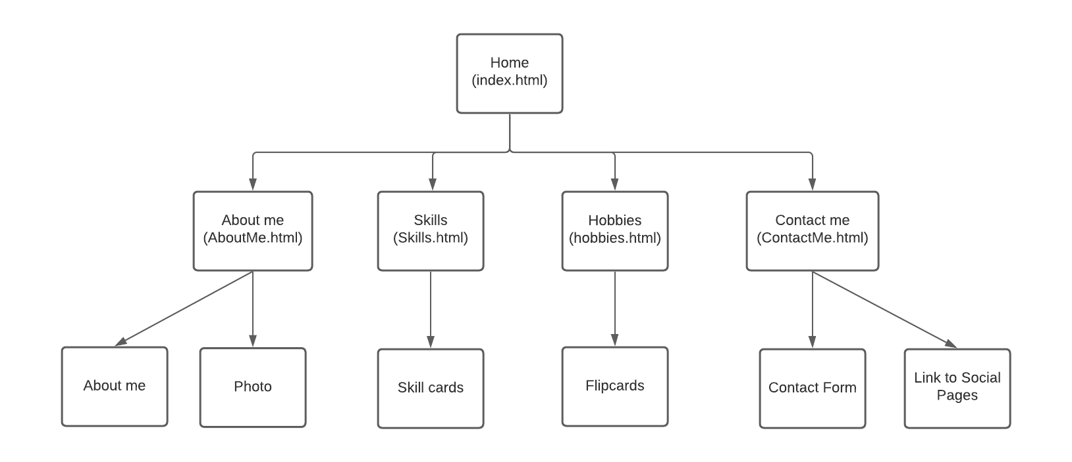

Home Page: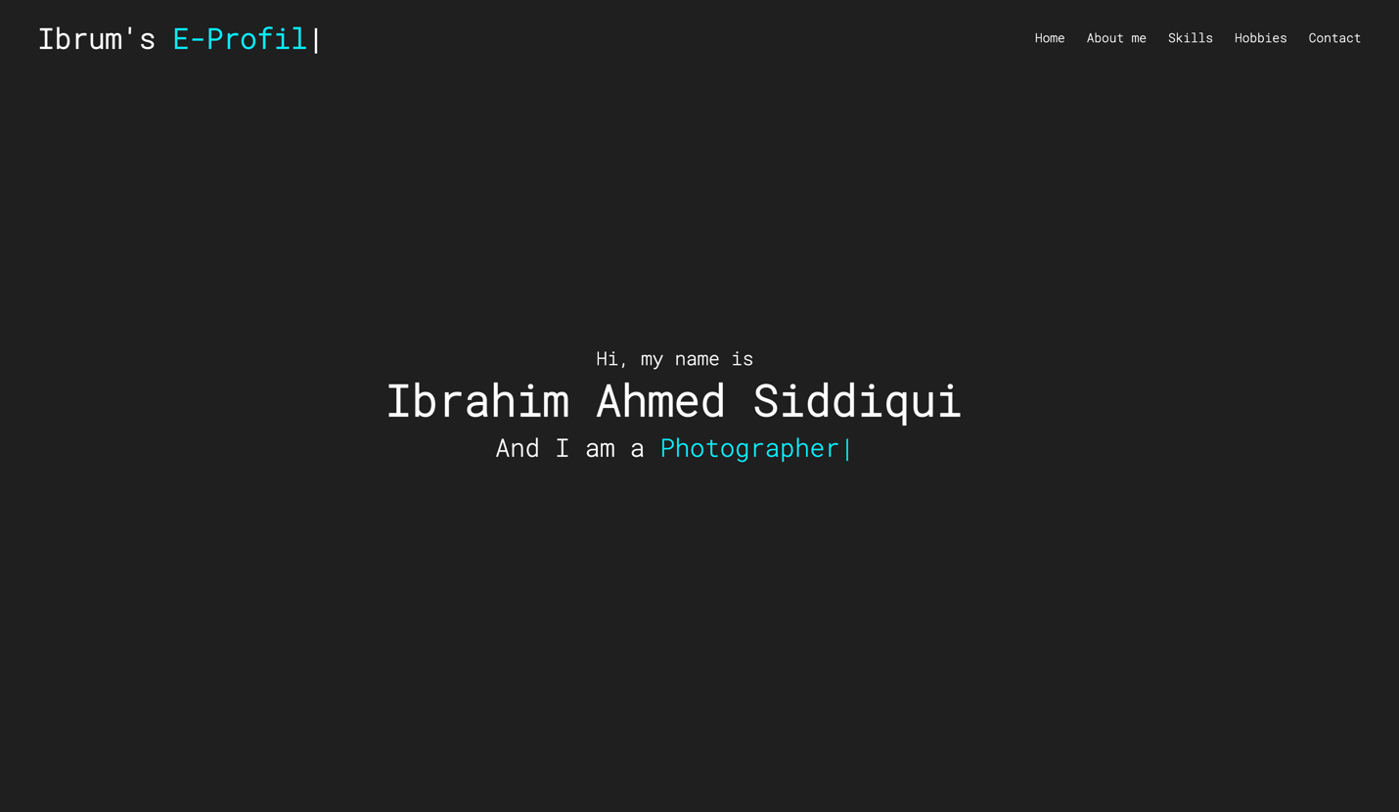

This is what my Home Page looks like. Here I introduce myself and I run some javascript to type out what my hobbies/passions are. At the top I have a nav bar that connects all of my pages together.

Here we have an about me page. I used the same js script as the home page to type out the DEVELOPER part. Then I have a small paragraph that explains who I am and what my passions are. Then I have a photo of me on the right.

Here I have a skills page which outlines what I’m good at. Each type of skill is a card with a border and a card shadow to give it a 3d effect. Each car contains the skills that I’m good at in each topic (the heading). The circles are just symbols that I’ve gotten from the internet.

Hobbies Page: 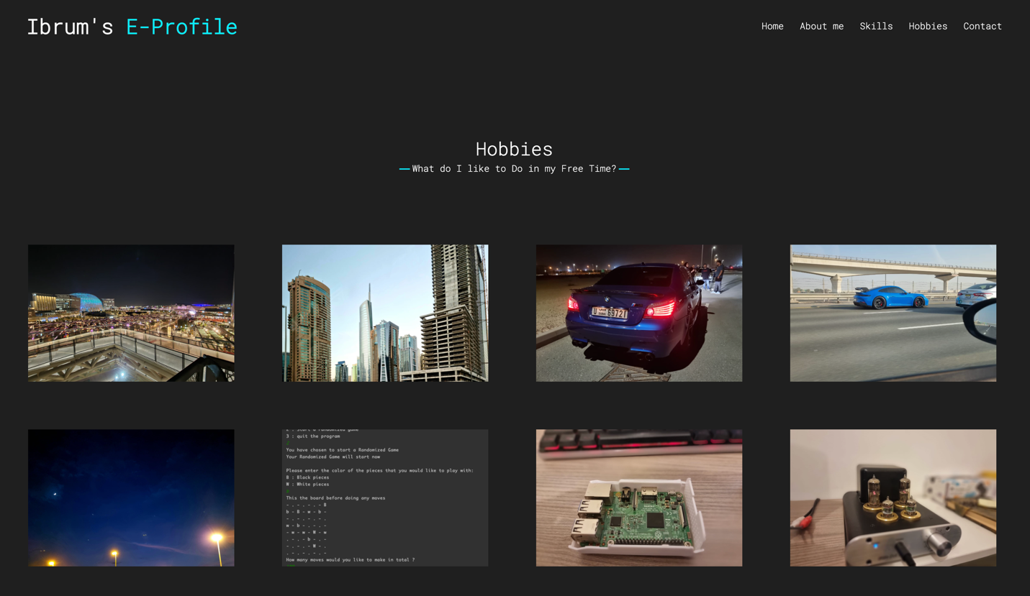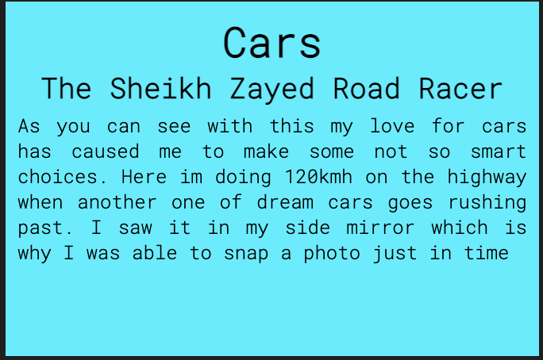

Here we have my Hobbies page which contains my hobbies. Here each photo is a flip card that flips to show which of my hobby it is and what is the photos meaning to me. I used tables to format each photo/flip card and to put them in a grid sort of pattern. The photo is an example of what the back of a flip card can look like. This particular back is for the top right most photo.

# Contact page:

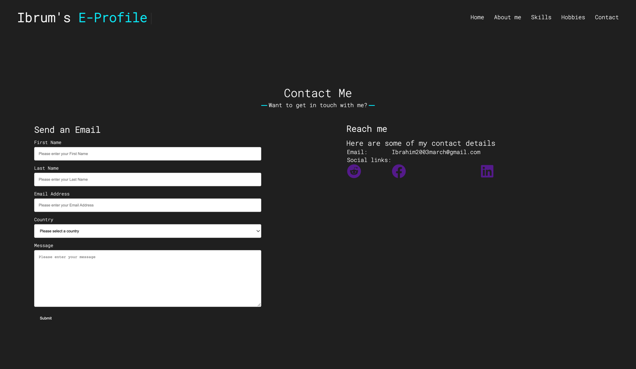

On the left we have a simple form to contact me. The javascript file that I have checks whether or not the fields are filled and if they are in the correct format. On the right we have a table which shows the different ways to contact me inlcuding links to my social accounts

# Code:

## Html:

### Index/Home page:

<!DOCTYPE html>

<html lang="en">

<head>

<script src="https://code.jquery.com/jquery-3.6.0.js"></script>

<meta charset="UTF-8">

<meta name="viewport" content="width=device-width, initial-scale=1.0">

<title>Ibrahims Portfolio</title>

<link rel="stylesheet" href="style.css">

<script src="https://use.fontawesome.com/releases/v5.15.0/js/all.js"></script>

<script src="https://cdnjs.cloudflare.com/ajax/libs/typed.js/2.0.12/typed.min.js"></script>

<script src="/JS/script.js"></script>

</head>

<body>

<nav class="Nbar">

<div class="Mwidth">

<div class="logo"><a href="#"> <span class="Titles"></span></a></div>

<ul class="navmenu">

<li><a href="index.html">Home</a></li>

<li><a href="AboutMe.html">About me</a></li>

<li><a href="Skills.html">Skills</a></li>

<li><a href="Hobbies.html">Hobbies</a></li>

<li><a href="ContactMe.html">Contact</a></li>

</ul>

<div class="Mbtn">

<i class="fas fa-ellipsis-v"></i>

</div>

</div>

</nav>

<section class="HPage">

<div class="Mwidth">

<div class="HPGContent">

<div class="T1">Hi, my name is</div>

<div class="T2">Ibrahim Ahmed Siddiqui</div>

<div class="T3">And I am a <span class="TYP1">Computer Science Major</span></div>

</div>

</div>

</section>

</body>

</html>

### About Me:

<!DOCTYPE html>

<html lang="en">

<head>

<script src="https://code.jquery.com/jquery-3.6.0.js"></script>

<meta charset="UTF-8">

<meta name="viewport" content="width=device-width, initial-scale=1.0">

<title>Ibrahims Portfolio</title>

<link rel="stylesheet" href="style.css">

<script src="https://use.fontawesome.com/releases/v5.15.0/js/all.js"></script>

<script src="https://cdnjs.cloudflare.com/ajax/libs/typed.js/2.0.12/typed.min.js"></script>

<script src="/JS/script.js"></script>

</head>

<body>

<nav class="Nbar">

<div class="Mwidth">

<div class="logo"><a href="#"> <span class="Titles"></span></a></div>

<ul class="navmenu">

<li><a href="index.html">Home</a></li>

<li><a href="AboutMe.html">About me</a></li>

<li><a href="Skills.html">Skills</a></li>

<li><a href="Hobbies.html">Hobbies</a></li>

<li><a href="ContactMe.html">Contact</a></li>

</ul>

<div class="Mbtn">

<i class="fas fa-ellipsis-v"></i>

</div>

</div>

</nav>

<section class="Bout">

<div class="Mwidth">

<h2 class="title">About me</h2>

<div class="AContent">

<div class="Cleft">

<div class="TXT2">Hi, I'm Ibrahim and I'm a <span class="TYP1">Computer Science Major</span></div>

<p>Hi, my name is Ibrahim Siddiqui. I am an 18 year old student currently studying Computer Science at the University of Wollongong in Dubai. I am originally from Pakistan but I have lived most of my life in other countries notably South Africa, Qatar, Iran and the UAE. This website is a window for you to see into what my life is like, what my Hobbies and Passions are, and to see what my skills are. One of my biggest passions and my best self-taugh skill is Programming. Programming is one of the things that comes to me naturally, I use it to relax, when im stressed and when im bored. Another one of passions is Photography. My love for photography started when I had lived in South Africa, the scenery was soo beautiful there that I wanted away to capture that. I have many more hobbies and skills that I hope this webiste will convey to you.</p>

</div>

<div class="CRight">

<img src="/Photos/hijsis.jpeg" alt="Ibrum's the greatest">

</div>

</div>

</div>

</section>

</body>

</html>

### Skills:

<!DOCTYPE html>

<html lang="en">

<head>

<script src="https://code.jquery.com/jquery-3.6.0.js"></script>

<meta charset="UTF-8">

<meta name="viewport" content="width=device-width, initial-scale=1.0">

<title>Ibrahims Portfolio</title>

<link rel="stylesheet" href="style.css">

<script src="https://use.fontawesome.com/releases/v5.15.0/js/all.js"></script>

<script src="https://cdnjs.cloudflare.com/ajax/libs/typed.js/2.0.12/typed.min.js"></script>

<script src="/JS/script.js"></script>

</head>

<body>

<nav class="Nbar">

<div class="Mwidth">

<div class="logo"><a href="#"> <span class="Titles"></span></a></div>

<ul class="navmenu">

<li><a href="index.html">Home</a></li>

<li><a href="AboutMe.html">About me</a></li>

<li><a href="Skills.html">Skills</a></li>

<li><a href="Hobbies.html">Hobbies</a></li>

<li><a href="ContactMe.html">Contact</a></li>

</ul>

<div class="Mbtn">

<i class="fas fa-ellipsis-v"></i>

</div>

</div>

</nav>

<section class="skills">

<h2 class="title">Skills</h2>

<div class="Mwidth">

<div class="SContent">

<div class="row">

<div class="column">

<div class="card">

<h1 class="H1S"">General Use Skills</h1>

<h4>Microsoft Office Applications</h4>

<span class="sp">◉ ◉ ◉ ◉ ◉ ◉ ◉ ◯ ◯ ◯</span>

<h4>Markup Languages</h4>

<span class="sp">◉ ◉ ◉ ◉ ◉ ◉ ◉ ◉ ◯ ◯</span>

<h4>Presentations and Public Speaking</h4>

<span class="sp">◉ ◉ ◉ ◉ ◉ ◉ ◉ ◯ ◯ ◯</span>

</div>

</div>

<div class="column">

<div class="card">

<h1 class="H1S">Development Skills</h1>

<h4>Java</h4>

<span class="sp">◉ ◉ ◉ ◉ ◉ ◉ ◉ ◉ ◉ ◯</span>

<h4>Python</h4>

<span class="sp">◉ ◉ ◉ ◉ ◉ ◉ ◉ ◉ ◯ ◯</span>

<h4>C++</h4>

<span class="sp">◉ ◉ ◉ ◉ ◉ ◉ ◉ ◉ ◯ ◯</span>

<h4>MySQL</h4>

<span class="sp">◉ ◉ ◉ ◉ ◉ ◉ ◉ ◉ ◉ ◯</span>

<h4>Assembly Language</h4>

<span class="sp">◉ ◉ ◉ ◉ ◉ ◉ ◯ ◯ ◯ ◯</span>

<h4>Rust</h4>

<span class="sp">◉ ◉ ◉ ◉ ◉ ◉ ◉ ◯ ◯ ◯</span>

</div>

</div>

<div class="column">

<div class="card">

<h1 class="H1S">Specializations</h1>

<h4>Data Science</h4>

<span class="sp">◉ ◉ ◉ ◉ ◉ ◉ ◉ ◉ ◉ ◯</span>

<h4>Machine Learning</h4>

<span class="sp">◉ ◉ ◉ ◉ ◉ ◉ ◉ ◯ ◯ ◯</span>

</div>

</div>

<div class="column">

<div class="card">

<h1 class="H2S">Data Science</h1>

<h4>R</h4>

<span class="sp">◉ ◉ ◉ ◉ ◉ ◉ ◉ ◉ ◯ ◯</span>

<h4>Jupyter</h4>

<span class="sp">◉ ◉ ◉ ◉ ◉ ◉ ◯ ◯ ◯ ◯</span>

<h4>Pytorch</h4>

<span class="sp">◉ ◉ ◉ ◉ ◉ ◉ ◯ ◯ ◯ ◯</span>

<h4>Tensorflow</h4>

<span class="sp">◉ ◉ ◉ ◉ ◉ ◉ ◉ ◯ ◯ ◯</span>

</div>

</div>

</div>

</div>

</div>

</section>

</body>

</html>

### Hobbies:

<!DOCTYPE html>

<html lang="en">

<head>

<script src="https://code.jquery.com/jquery-3.6.0.js"></script>

<meta charset="UTF-8">

<meta name="viewport" content="width=device-width, initial-scale=1.0">

<title>Ibrahims Portfolio</title>

<link rel="stylesheet" href="style.css">

<script src="https://use.fontawesome.com/releases/v5.15.0/js/all.js"></script>

<script src="https://cdnjs.cloudflare.com/ajax/libs/typed.js/2.0.12/typed.min.js"></script>

<script src="/JS/script.js"></script>

</head>

<body>

<nav class="Nbar">

<div class="Mwidth">

<div class="logo"><a href="#"><span class="Titles"></span></a></div>

<ul class="navmenu">

<li><a href="index.html">Home</a></li>

<li><a href="AboutMe.html">About me</a></li>

<li><a href="Skills.html">Skills</a></li>

<li><a href="Hobbies.html">Hobbies</a></li>

<li><a href="ContactMe.html">Contact</a></li>

</ul>

<div class="Mbtn">

<i class="fas fa-ellipsis-v"></i>

</div>

</div>

</nav>

<section class="Hobbies">

<h2 class="title">Hobbies</h2>

<div class="Mwidth">

<table>

<tr>

<td class="td1">

<div class="flip-card">

<div class="flip-card-inner">

<div class="flip-card-front">

<img src="/Photos/exp1.jpeg" alt="Expo" class="img1"">

</div>

<div class="flip-card-back">

<h1 class="h">Photography</h1>

<h2>Expo 2020</h2>

<p class="Text">This Photo is very special to me. It was one of the very few times in my life where I have just stood in one place, looked at a view and simply enjoyed it</p>

</div>

</div>

</div>

</td>

<td class="td2">

<div class="flip-card">

<div class="flip-card-inner">

<div class="flip-card-front">

<img src="/Photos/Gen2.jpeg" alt="Expo" class="img1"">

</div>

<div class="flip-card-back">

<h1 class="h">Photography</h1>

<h2>Jumeirah Islands</h2>

<p class="Text">This Photo is also very special to me. It was the First times I went out in Dubai to do some photography</p>

</div>

</div>

</div>

</td>

<td class="td2">

<div class="flip-card">

<div class="flip-card-inner">

<div class="flip-card-front">

<img src="/Photos/m5.jpeg" alt="Expo" class="img1"">

</div>

<div class="flip-card-back">

<h1 class="h">Photography and Cars</h1>

<h2>Never meet your heroes</h2>

<p class="Text">This is a photo that combines two of my most favorite hobbies, Photography and Cars. In this photo we have an e60 m5 (It is one of my dream cars) on the side of the road at a car meet before we leave.</p>

</div>

</div>

</div>

</td>

<td class="td2">

<div class="flip-card">

<div class="flip-card-inner">

<div class="flip-card-front">

<img src="/Photos/gt3.jpeg" alt="Expo" class="img1">

</div>

<div class="flip-card-back">

<h1 class="h">Cars</h1>

<h2>The Sheikh Zayed Road Racer</h2>

<p class="Text">As you can see with this my love for cars has caused me to make some not so smart choices. Here im doing 120kmh on the highway when another one of dream cars goes rushing past. I saw it in my side mirror which is why I was able to snap a photo just in time</p>

</div>

</div>

</div>

</td>

</tr>

<tr>

<td class="td1">

<div class="flip-card">

<div class="flip-card-inner">

<div class="flip-card-front">

<img src="/Photos/photo2.jpeg" alt="Expo"class="img1" >

</div>

<div class="flip-card-back">

<h1 class="h">Photography</h1>

<h2>Dancing in the Moonlight</h2>

<p class="Text">This Photo is very special to me. It was one of the very few times in my life where I have just stood in one place, looked at a view and simply enjoyed it</p>

</div>

</div>

</div>

</td>

<td class="td2">

<div class="flip-card">

<div class="flip-card-inner">

<div class="flip-card-front">

<img src="/Photos/code.png" alt="Expo" class="img1">

</div>

<div class="flip-card-back">

<h1 class="h">Programming</h1>

<h2>Programmer Brogramer</h2>

<p class="Text">This Photo is also very special to me. It was the First times I went out in Dubai to do some photography</p>

</div>

</div>

</div>

</td>

<td class="td2">

<div class="flip-card">

<div class="flip-card-inner">

<div class="flip-card-front">

<img src="/Photos/tech.jpeg" alt="Expo" class="img1">

</div>

<div class="flip-card-back">

<h1 class="h">Technology</h1>

<h2>David and Goliath</h2>

<p class="Text">This is a photo that combines two of my most favorite hobbies, Photography and Cars. In this photo we have an e60 m5 (It is one of my dream cars) on the side of the road at a car meet before we leave.</p>

</div>

</div>

</div>

</td>

<td class="td2">

<div class="flip-card">

<div class="flip-card-inner">

<div class="flip-card-front">

<img src="/Photos/Audiophile.jpeg" alt="Expo" class="img1">

</div>

<div class="flip-card-back">

<h1 class="h">Audiophile</h1>

<h2>Musical Love</h2>

<p class="Text">This Photo is also very special to me. It was the First times I went out in Dubai to do some photography</p>

</div>

</div>

</div>

</td>

</tr>

</table>

</div>

</section>

</body>

</html>

### Contact Me:

<!DOCTYPE html>

<html lang="en">

<head>

<script src="https://code.jquery.com/jquery-3.6.0.js"></script>

<meta charset="UTF-8">

<meta name="viewport" content="width=device-width, initial-scale=1.0">

<title>Ibrahims Portfolio</title>

<link rel="stylesheet" href="style.css">

<link rel="stylesheet" href="https://cdnjs.cloudflare.com/ajax/libs/font-awesome/6.0.0/css/all.min.css" integrity="sha512-9usAa10IRO0HhonpyAIVpjrylPvoDwiPUiKdWk5t3PyolY1cOd4DSE0Ga+ri4AuTroPR5aQvXU9xC6qOPnzFeg==" crossorigin="anonymous" referrerpolicy="no-referrer" />

<script src="https://cdnjs.cloudflare.com/ajax/libs/typed.js/2.0.12/typed.min.js"></script>

<script src="/JS/script.js"></script>

</head>

<body>

<nav class="Nbar">

<div class="Mwidth">

<div class="logo"><a href="#"> <span class="Titles"></span></a></div>

<ul class="navmenu">

<li><a href="index.html">Home</a></li>

<li><a href="AboutMe.html">About me</a></li>

<li><a href="Skills.html">Skills</a></li>

<li><a href="Hobbies.html">Hobbies</a></li>

<li><a href="ContactMe.html">Contact</a></li>

</ul>

<div class="Mbtn">

<i class="fas fa-ellipsis-v"></i>

</div>

</div>

</nav>

<section class="ContactMe" id="Contact">

<div class="Mwidth">

<h2 class="title">Contact Me</h2>

<div class="CContent">

<div class="Cleft">

<h3>Send an Email</h3>

<form onSubmit="validateForm()" method="get" name="form">

<label for="FName">First Name</label>

<input type="text" id="FName" name="FName" placeholder="Please enter your First Name">

<label for="LName">Last Name</label>

<input type="text" id="LName" name="LName" placeholder="Please enter your Last Name">

<label for="Email">Email Address</label>

<input type="email" id="Email" name="Email" placeholder="Please enter your Email Address">

<label for="CCountry">Country</label>

<select id="CCountry" name="CCountry">

<option value="place" disabled selected>Please select a country</option>

<option value="Andorra">Andorra</option>

<option value="Angola">Angola</option>

<option value="Anguilla">Anguilla</option>

<option value="Antigua & Barbuda">Antigua & Barbuda</option>

<option value="Argentina">Argentina</option>

<option value="Armenia">Armenia</option>

<option value="Aruba">Aruba</option>

<option value="Australia">Australia</option>

<option value="Austria">Austria</option>

<option value="Azerbaijan">Azerbaijan</option>

<option value="Bahamas">Bahamas</option>

<option value="Bahrain">Bahrain</option>

<option value="Bangladesh">Bangladesh</option>

<option value="Barbados">Barbados</option>

<option value="Belarus">Belarus</option>

<option value="Belgium">Belgium</option>

<option value="Belize">Belize</option>

<option value="Benin">Benin</option>

<option value="Bermuda">Bermuda</option>

<option value="Bhutan">Bhutan</option>

<option value="Bolivia">Bolivia</option>

<option value="Bonaire">Bonaire</option>

<option value="Bosnia & Herzegovina">Bosnia & Herzegovina</option>

<option value="Botswana">Botswana</option>

<option value="Brazil">Brazil</option>

<option value="British Indian Ocean Ter">British Indian Ocean Ter</option>

<option value="Brunei">Brunei</option>

<option value="Bulgaria">Bulgaria</option>

<option value="Burkina Faso">Burkina Faso</option>

<option value="Burundi">Burundi</option>

<option value="Cambodia">Cambodia</option>

<option value="Cameroon">Cameroon</option>

<option value="Canada">Canada</option>

<option value="Canary Islands">Canary Islands</option>

<option value="Cape Verde">Cape Verde</option>

<option value="Cayman Islands">Cayman Islands</option>

<option value="Central African Republic">Central African Republic</option>

<option value="Chad">Chad</option>

<option value="Channel Islands">Channel Islands</option>

<option value="Chile">Chile</option>

<option value="China">China</option>

<option value="Christmas Island">Christmas Island</option>

<option value="Cocos Island">Cocos Island</option>

<option value="Colombia">Colombia</option>

<option value="Comoros">Comoros</option>

<option value="Congo">Congo</option>

<option value="Cook Islands">Cook Islands</option>

<option value="Costa Rica">Costa Rica</option>

<option value="Cote DIvoire">Cote DIvoire</option>

<option value="Croatia">Croatia</option>

<option value="Cuba">Cuba</option>

<option value="Curaco">Curacao</option>

<option value="Cyprus">Cyprus</option>

<option value="Czech Republic">Czech Republic</option>

<option value="Denmark">Denmark</option>

<option value="Djibouti">Djibouti</option>

<option value="Dominica">Dominica</option>

<option value="Dominican Republic">Dominican Republic</option>

<option value="East Timor">East Timor</option>

<option value="Ecuador">Ecuador</option>

<option value="Egypt">Egypt</option>

<option value="El Salvador">El Salvador</option>

<option value="Equatorial Guinea">Equatorial Guinea</option>

<option value="Eritrea">Eritrea</option>

<option value="Estonia">Estonia</option>

<option value="Ethiopia">Ethiopia</option>

<option value="Falkland Islands">Falkland Islands</option>

<option value="Faroe Islands">Faroe Islands</option>

<option value="Fiji">Fiji</option>

<option value="Finland">Finland</option>

<option value="France">France</option>

<option value="French Guiana">French Guiana</option>

<option value="French Polynesia">French Polynesia</option>

<option value="French Southern Ter">French Southern Ter</option>

<option value="Gabon">Gabon</option>

<option value="Gambia">Gambia</option>

<option value="Georgia">Georgia</option>

<option value="Germany">Germany</option>

<option value="Ghana">Ghana</option>

<option value="Gibraltar">Gibraltar</option>

<option value="Great Britain">Great Britain</option>

<option value="Greece">Greece</option>

<option value="Greenland">Greenland</option>

<option value="Grenada">Grenada</option>

<option value="Guadeloupe">Guadeloupe</option>

<option value="Guam">Guam</option>

<option value="Guatemala">Guatemala</option>

<option value="Guinea">Guinea</option>

<option value="Guyana">Guyana</option>

<option value="Haiti">Haiti</option>

<option value="Hawaii">Hawaii</option>

<option value="Honduras">Honduras</option>

<option value="Hong Kong">Hong Kong</option>

<option value="Hungary">Hungary</option>

<option value="Iceland">Iceland</option>

<option value="Indonesia">Indonesia</option>

<option value="India">India</option>

<option value="Iran">Iran</option>

<option value="Iraq">Iraq</option>

<option value="Ireland">Ireland</option>

<option value="Isle of Man">Isle of Man</option>

<option value="Israel">Israel</option>

<option value="Italy">Italy</option>

<option value="Jamaica">Jamaica</option>

<option value="Japan">Japan</option>

<option value="Jordan">Jordan</option>

<option value="Kazakhstan">Kazakhstan</option>

<option value="Kenya">Kenya</option>

<option value="Kiribati">Kiribati</option>

<option value="Korea North">Korea North</option>

<option value="Korea Sout">Korea South</option>

<option value="Kuwait">Kuwait</option>

<option value="Kyrgyzstan">Kyrgyzstan</option>

<option value="Laos">Laos</option>

<option value="Latvia">Latvia</option>

<option value="Lebanon">Lebanon</option>

<option value="Lesotho">Lesotho</option>

<option value="Liberia">Liberia</option>

<option value="Libya">Libya</option>

<option value="Liechtenstein">Liechtenstein</option>

<option value="Lithuania">Lithuania</option>

<option value="Luxembourg">Luxembourg</option>

<option value="Macau">Macau</option>

<option value="Macedonia">Macedonia</option>

<option value="Madagascar">Madagascar</option>

<option value="Malaysia">Malaysia</option>

<option value="Malawi">Malawi</option>

<option value="Maldives">Maldives</option>

<option value="Mali">Mali</option>

<option value="Malta">Malta</option>

<option value="Marshall Islands">Marshall Islands</option>

<option value="Martinique">Martinique</option>

<option value="Mauritania">Mauritania</option>

<option value="Mauritius">Mauritius</option>

<option value="Mayotte">Mayotte</option>

<option value="Mexico">Mexico</option>

<option value="Midway Islands">Midway Islands</option>

<option value="Moldova">Moldova</option>

<option value="Monaco">Monaco</option>

<option value="Mongolia">Mongolia</option>

<option value="Montserrat">Montserrat</option>

<option value="Morocco">Morocco</option>

<option value="Mozambique">Mozambique</option>

<option value="Myanmar">Myanmar</option>

<option value="Nambia">Nambia</option>

<option value="Nauru">Nauru</option>

<option value="Nepal">Nepal</option>

<option value="Netherland Antilles">Netherland Antilles</option>

<option value="Netherlands">Netherlands (Holland, Europe)</option>

<option value="Nevis">Nevis</option>

<option value="New Caledonia">New Caledonia</option>

<option value="New Zealand">New Zealand</option>

<option value="Nicaragua">Nicaragua</option>

<option value="Niger">Niger</option>

<option value="Nigeria">Nigeria</option>

<option value="Niue">Niue</option>

<option value="Norfolk Island">Norfolk Island</option>

<option value="Norway">Norway</option>

<option value="Oman">Oman</option>

<option value="Pakistan">Pakistan</option>

<option value="Palau Island">Palau Island</option>

<option value="Palestine">Palestine</option>

<option value="Panama">Panama</option>

<option value="Papua New Guinea">Papua New Guinea</option>

<option value="Paraguay">Paraguay</option>

<option value="Peru">Peru</option>

<option value="Phillipines">Philippines</option>

<option value="Pitcairn Island">Pitcairn Island</option>

<option value="Poland">Poland</option>

<option value="Portugal">Portugal</option>

<option value="Puerto Rico">Puerto Rico</option>

<option value="Qatar">Qatar</option>

<option value="Republic of Montenegro">Republic of Montenegro</option>

<option value="Republic of Serbia">Republic of Serbia</option>

<option value="Reunion">Reunion</option>

<option value="Romania">Romania</option>

<option value="Russia">Russia</option>

<option value="Rwanda">Rwanda</option>

<option value="St Barthelemy">St Barthelemy</option>

<option value="St Eustatius">St Eustatius</option>

<option value="St Helena">St Helena</option>

<option value="St Kitts-Nevis">St Kitts-Nevis</option>

<option value="St Lucia">St Lucia</option>

<option value="St Maarten">St Maarten</option>

<option value="St Pierre & Miquelon">St Pierre & Miquelon</option>

<option value="St Vincent & Grenadines">St Vincent & Grenadines</option>

<option value="Saipan">Saipan</option>

<option value="Samoa">Samoa</option>

<option value="Samoa American">Samoa American</option>

<option value="San Marino">San Marino</option>

<option value="Sao Tome & Principe">Sao Tome & Principe</option>

<option value="Saudi Arabia">Saudi Arabia</option>

<option value="Senegal">Senegal</option>

<option value="Seychelles">Seychelles</option>

<option value="Sierra Leone">Sierra Leone</option>

<option value="Singapore">Singapore</option>

<option value="Slovakia">Slovakia</option>

<option value="Slovenia">Slovenia</option>

<option value="Solomon Islands">Solomon Islands</option>

<option value="Somalia">Somalia</option>

<option value="South Africa">South Africa</option>

<option value="Spain">Spain</option>

<option value="Sri Lanka">Sri Lanka</option>

<option value="Sudan">Sudan</option>

<option value="Suriname">Suriname</option>

<option value="Swaziland">Swaziland</option>

<option value="Sweden">Sweden</option>

<option value="Switzerland">Switzerland</option>

<option value="Syria">Syria</option>

<option value="Tahiti">Tahiti</option>

<option value="Taiwan">Taiwan</option>

<option value="Tajikistan">Tajikistan</option>

<option value="Tanzania">Tanzania</option>

<option value="Thailand">Thailand</option>

<option value="Togo">Togo</option>

<option value="Tokelau">Tokelau</option>

<option value="Tonga">Tonga</option>

<option value="Trinidad & Tobago">Trinidad & Tobago</option>

<option value="Tunisia">Tunisia</option>

<option value="Turkey">Turkey</option>

<option value="Turkmenistan">Turkmenistan</option>

<option value="Turks & Caicos Is">Turks & Caicos Is</option>

<option value="Tuvalu">Tuvalu</option>

<option value="Uganda">Uganda</option>

<option value="United Kingdom">United Kingdom</option>

<option value="Ukraine">Ukraine</option>

<option value="United Arab Emirates">United Arab Emirates</option>

<option value="United States of America">United States of America</option>

<option value="Uraguay">Uruguay</option>

<option value="Uzbekistan">Uzbekistan</option>

<option value="Vanuatu">Vanuatu</option>

<option value="Vatican City State">Vatican City State</option>

<option value="Venezuela">Venezuela</option>

<option value="Vietnam">Vietnam</option>

<option value="Virgin Islands (Brit)">Virgin Islands (Brit)</option>

<option value="Virgin Islands (USA)">Virgin Islands (USA)</option>

<option value="Wake Island">Wake Island</option>

<option value="Wallis & Futana Is">Wallis & Futana Islands</option>

<option value="Yemen">Yemen</option>

<option value="Zaire">Zaire</option>

<option value="Zambia">Zambia</option>

<option value="Zimbabwe">Zimbabwe</option>

</select>

<label for="MSSG">Message</label>

<textarea id="MSSG" name="MSSG" placeholder="Please enter your message" style="height:200px"></textarea>

<input type="submit" value="Submit">

</form>

</div>

<div class="CRight">

<h3>Reach me</h3>

<p style="font-size: 25px;">Here are some of my contact details</p>

<table>

<tr>

<td style="font-size: 20px;">Email:</td>

<td style="font-size: 20px">Ibrahim2003march@gmail.com</td>

</tr>

<tr>

<td style="font-size: 20px;">Social links:</td>

</tr>

<tr>

<td class="reddit"><a href="https://www.reddit.com/user/Zephyr__100"><i class="fa-brands fa-reddit" style="font-size: 50px;"></i></a></td>

<td class="facebook"><a href="https://www.facebook.com/ibrahim.siddiqui.902/"><i class="fa-brands fa-facebook" style="font-size: 50px;"></i></a></td>

<td class="linked"><a href="https://www.linkedin.com/in/ibrahim-siddiqui-779569214/"><i class="fa-brands fa-linkedin" style="font-size: 50px;"></i></a></td>

</tr>

</table>

</div>

</div>

</div>

</section>

</body>

</html>

## CSS for All Page:

*@import* url('https://fonts.googleapis.com/css2?family=Roboto+Mono:wght@300&display=swap');

body{

background-color: #1f1f1f;

font-family: 'Roboto Mono', monospace;

}

*{

margin: 0;

padding: 0;

box-sizing: border-box;

text-decoration: none ;

}

.Nbar {

position: fixed;

width: 100%;

font-family: 'Roboto Mono', monospace;

padding: 30px 0px;

}

.Nbar .navmenu li a{

color: #ffffff;

font-size: 20px;

font-weight: 500;

margin-left: 25px;

transition: color 0.5s ease-in;

}

.Nbar .navmenu li a:hover{

color: #00eeff;

}

.Nbar .navmenu li{

list-style: none;

display: inline-block;

}

.Nbar .logo a{

color: #ffffff;

font-size: 45px;

font-weight: 600;

}

.Nbar .logo a .blue{

color:#00eeff;

transition: all 0.32s ease-in;

}

.Mwidth{

max-width: 2560px;

padding: 0 60px;

margin: auto;

}

.Nbar .Mwidth{

display: flex;

align-items: center;

justify-content: space-between;

}

.HPage{

display: flex;

background: #1f1f1f;

background-size: cover;

height: 100vh;

color: #ffffff;

min-height: 500px;

font-family: 'Roboto Mono', monospace;

text-align: center;

align-items: center;

}

.HPage .Mwidth{

margin: auto 0 auto 25%;

}

.HPage .HPGContent .T1{

font-size: 30px;

}

.HPage .HPGContent .T2{

font-size: 70px;

font-weight: 600;

margin-left: -3px;

}

.HPage .HPGContent .T3{

font-size: 40px;

margin: 5px 0;

}

.HPage .HPGContent .T3 span{

color: #00eeff;

font-weight: 500;

}

.Mbtn{

color: #00eeff;

font-size: 23px;

cursor: pointer;

display: none;

}

.Bout{

padding-top: 300px;

padding-left: 50px;

color: white;

}

section .title{

position: relative;

text-align: center;

font-size: 40px;

font-weight: 500;

margin-bottom: 60px;

padding-bottom: 20px;

color: white;

}

section .title::before{

content: "";

position: absolute;

bottom: 0px;

left: 50%;

width: 300px;

height: 3px;

background: #00eeff;

transform: translateX(-50%);

}

section .title::after{

position: absolute;

bottom: -15px;

left: 50%;

font-size: 20px;

padding:5px;

color: white;

background: #1f1f1f;

transform: translateX(-50%);

}

.Bout .AContent{

display: flex;

flex-wrap: wrap;

align-items: center;

justify-content: space-between;

}

.Bout .AContent .CRight{

width: 45%;

}

.Bout .AContent .CRight img{

width: 700px;

height: 700px;

object-fit: cover;

margin: 0 200px;

}

.Bout .AContent .Cleft{

width: 55%;

}

.Bout .AContent .Cleft p{

font-size: 20px;

text-align: justify;

}

.Bout .AContent .Cleft .TXT2{

font-size: 30px;

margin-bottom: 15px;

}

.Bout .AContent .Cleft .TXT2 span{

color: #00eeff;

}

.Bout .title::after{

content: "Who Am I?";

}

.skills{

padding-top: 300px;

}

.skills .title::after{

content: "What Am I Good At?";

}

.column {

float: left;

width: 25%;

padding: 0 10px;

}

.row {

padding-top: 100px;

margin: 0 -5px;

}

.card {

box-shadow: 0 4px 8px 0 rgba(0, 0, 0, 0.2); */* this adds the "card" effect */*

padding: 16px;

text-align: center;

background-color: #1f1f1f;

color: white;

padding-bottom: 100px;

}

.H1S{

font-size: 30px;

padding-bottom: 40px;

padding-top: 10px;

}

.H2S{

font-size: 30px;

padding-bottom: 30px;

padding-top: 30px;

}

.card .sp{

font-size: 20px;

}

.card h4{

color: #00eeff;

font-size: 20px;

padding-top: 10px;

padding-bottom: 15px;

}

.Hobbies{

padding-top: 300px;

}

.Hobbies .title::before{

content: "";

position: absolute;

bottom: 0px;

left: 50%;

width: 500px;

height: 3px;

background: #00eeff;

transform: translateX(-50%);

}

.Hobbies .title::after{

content: "What do I like to Do in my Free Time?";

}

.ContactMe{

padding-top: 300px;

}

.ContactMe .CContent{

display: flex;

flex-wrap: wrap;

align-items: center;

justify-content: space-between;

color: white;

}

.ContactMe .title::before{

content: "";

position: absolute;

bottom: 0px;

left: 50%;

width: 400px;

height: 3px;

background: #00eeff;

transform: translateX(-50%);

}

.ContactMe .title::after{

content: "Want to get in touch with me?";

}

.ContactMe .CContent .CRight{

width: 50%;

padding-left: 100px;

padding-bottom: 515px;

}

.ContactMe .CContent .Cleft{

width: 50%;

padding-left: 60px;

border-radius: 5px;

padding-right: 200px;

}

*@media* (max-width:947px){

.Mwidth{

padding: 0px 50px;

}

.Mbtn{

display: block;

z-index: 947px;

}

.Nbar .navmenu{

position: fixed;

height: 100vh;

width: 100%;

left: -100;

top: 0;

background: #141414;

text-align: center;

padding-top: 80px;

transition: all 0.5s ease;

}

.Nbar .navmenu.active{

left: 0;

}

.Nbar .navmenu li {

display: block;

}

.Nbar .navmenu li a{

display: inline-block;

margin: 25px 0;

font-size: 30px;

}

.HPage .HPGContent .T2{

font-size: 70px;

}

.HPage .HPGContent .T3{

font-size: 35px;

}

}

.flip-card {

background-color: transparent;

width: 450px;

height: 300px;

border: 1px solid #1f1f1f;

perspective: 1000px; */* Remove this if you don't want the 3D effect */*

}

.flip-card-inner{

position: relative;

width: 100%;

height: 100%;

text-align: center;

transition: transform 0.8s;

transform-style: preserve-3d;

}

.flip-card:hover .flip-card-inner {

transform: rotateY(180deg);

}

.flip-card-front, .flip-card-back {

position: absolute;

width: 100%;

height: 100%;

-webkit-backface-visibility: hidden; */* Safari */*

backface-visibility: hidden;

}

.h{

font-size: 35px;

padding-top: 10px;

}

.flip-card-front {

background-color: #1f1f1f;

color: rgb(255, 255, 255);

}

.flip-card-back {

background-color: #00eeff;

color: rgb(0, 0, 0);

transform: rotateY(180deg);

}

.td1{

padding-top: 100px;

padding-left: px;

}

.Text{

padding-left: 10px;

padding-right: 10px;

padding-top: 5px;

text-align: justify;

}

.td2{

padding-top: 100px;

padding-left: 100px;

}

.img1{

object-fit: cover;

width: 100%;

height: 100%;

}

.ContactMe .CContent h3{

padding-bottom: 15px;

font-size: 30px;

}

input[type=text], input[type=email], select, textarea{

width:100%;

padding: 15px;

border: 1px solid #ccc;

border-radius: 4px;

box-sizing: border-box;

margin-top: 6px;

margin-bottom: 16px;

resize: vertical

}

input[type=submit] {

background-color: #1f1f1f;

color: rgb(255, 255, 255);

padding: 12px 20px;

border: white;

border-radius: 4px;

cursor: pointer;

}

input[type=submit]:hover {

background-color: #00eeff;

color: #141414;

}

### JavaScript:

$(document).ready(function()

{

var typed = new Typed(".TYP1",{

strings:["","Developer","Photographer","Guitarist","Audiophile","Techie","Car Enthusiast"],

typeSpeed: 100,

backSpeed: 60,

loop: true

});

});

$(document).ready(function()

{

var typed = new Typed(".Titles",{

strings:["Ibrum's <span style='color:#00eeff'>E-Profile</span>"],

typeSpeed: 100,

backSpeed: 60,

loop: true

});

});

function validateForm(){

*if* (document.getElementById("FName").value === "" && !(document.getElementById("LName").value).match(/*^*[0-9]+*$*/)) {

alert("The First Name Cannot Be empty")

}

*if* (document.getElementById("LName").value === "" && !(document.getElementById("LName").value).match(/*^*[0-9]+*$*/)) {

alert("The Last Name Cannot Be empty")

}

*if* (!(document.getElementById("Email").value.match(/*^*\w+([\.-]?\w+)*@\w+([\.-]?\w+)*(\.\w{2,3})+*$*/)))

{

alert("You have entered an invalid email address!")

}

*if* (document.getElementById("CCountry").value === "")

{

alert("Please Select a Country")

}

*if* (document.getElementById("MSSG").value === "")

{

alert("Please enter a Message")

}

*if* (!(document.getElementById("FName").value === "")&&!(document.getElementById("LName").value === "")&&(document.getElementById("Email").value.match(/*^*\w+([\.-]?\w+)*@\w+([\.-]?\w+)*(\.\w{2,3})+*$*/))&&!(document.getElementById("CCountry").value === "")&&!(document.getElementById("MSSG").value === ""))

{

alert("Success ur message was sent")

}

}

Photos used in the program:

